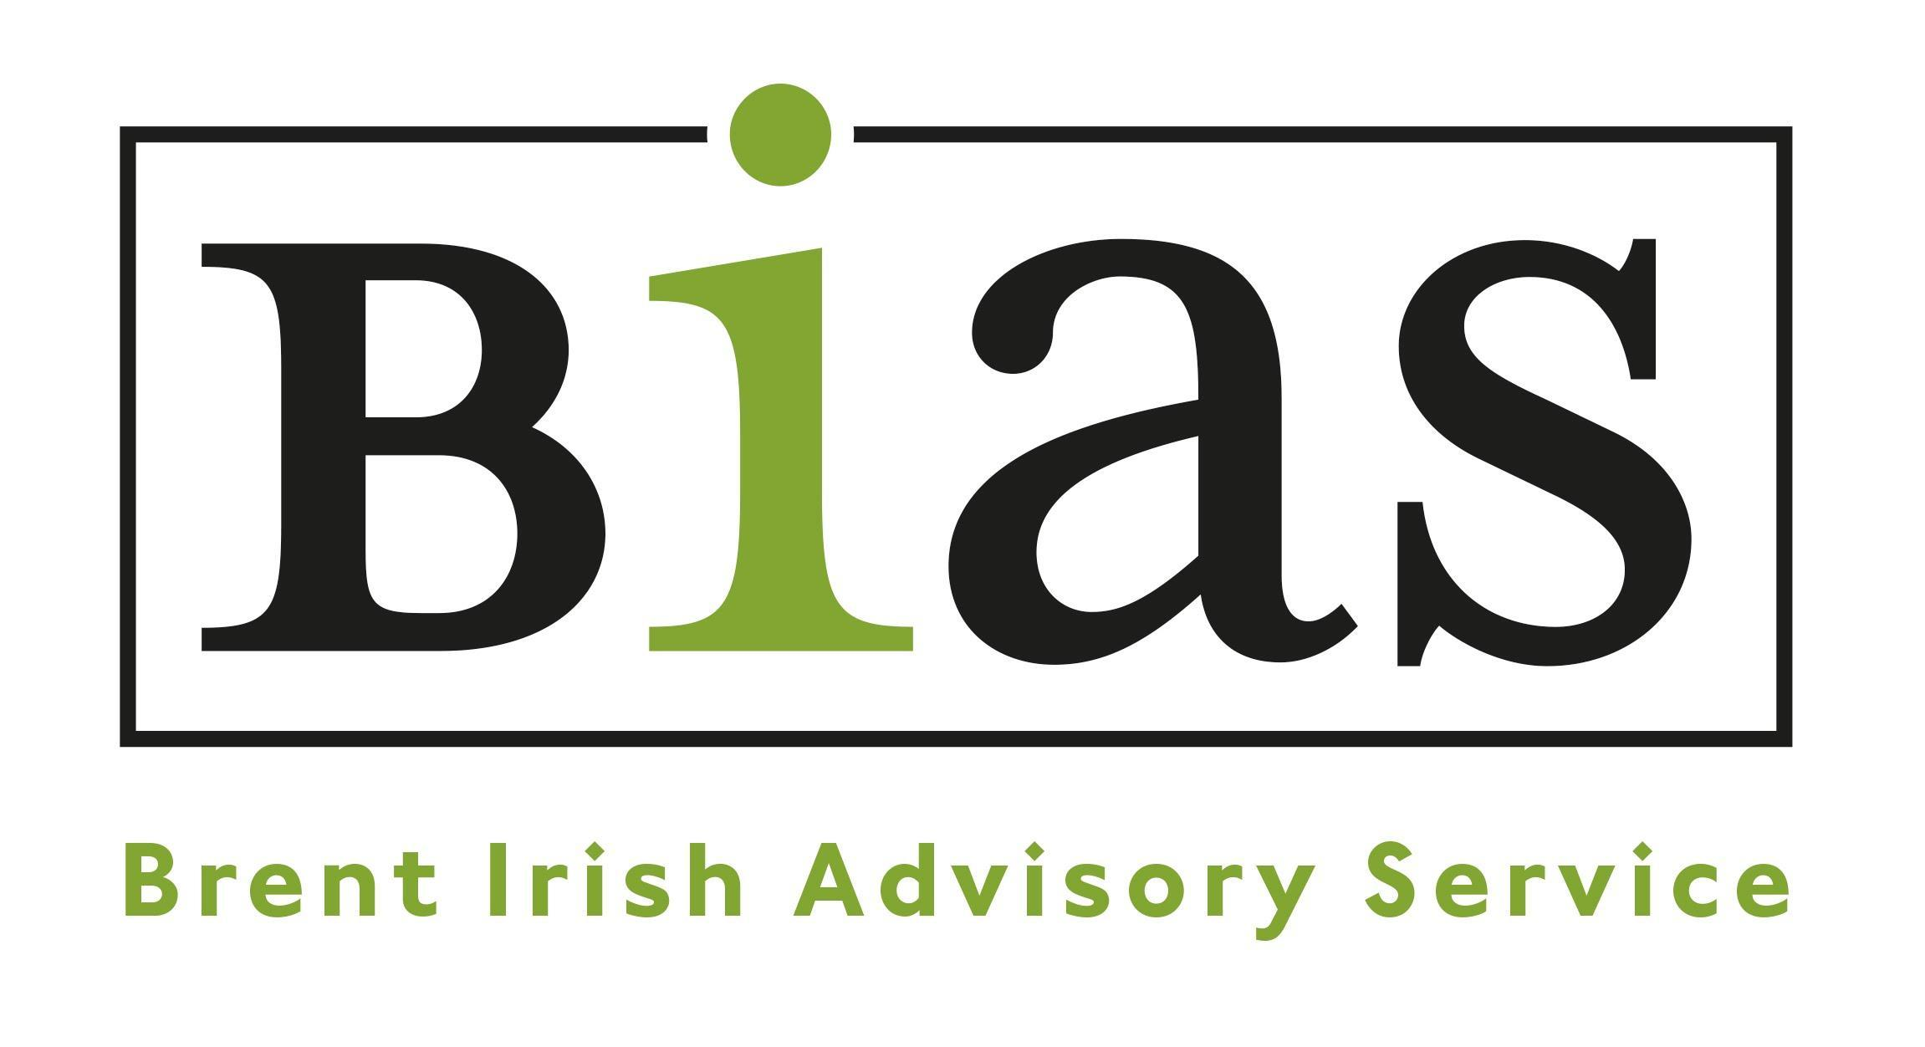

JOB DESCRIPTION

Title: Poverty (Outreach Advice) Worker
Responsible to: Director/Advice Manager
Hours: Full time 35 hrs weekly.
Position(s) include occasional evening or weekend work.
Salary: £29,000 - £31000 (pro rata based on FT post) depending on experience and qualifications.
Based: 379-381 High Road, Willesden, NW10 2JR + other locations required for service delivery within the London borough of Brent. Flexibility to work from home
Contract: 2 -5 years (subject to satisfactory performance)

Closing Date: 4 June 2021 midday
Interviews: week commencing 14 June

Please Note: Enhanced DBS is required for this role

JOB PURPOSE

BIAS has supported London’s largest Irish Community in Brent and North London for over forty years. We deliver our support through our welfare advice drop-in service and through our Active Ageing Thursday Club.

We would like to appointment a dynamic, enthusiastic person to provide a hands-on approach in the delivery of BIAS frontline services. Your role will involve contributing to running of day-to-day services alongside existing welfare staff. Key to your role will be providing one-to-one appointments on complex welfare areas, development of an outreach home service and support to clients in preparation for tribunal hearings.

You will need to have strong people skills (working with staff, volunteers and clients), excellent organisational skills and ability to digest complex briefs. You will be required to manage an active caseload ensuring cases are appropriately actioned and recorded while ensuring tasks and deadlines are consistently achieved. This role is subject to funding and is reviewed on an annual basis.

You will need to be confident in all areas of welfare law, particularly those relating to pension-age benefits and be able to advocate for clients at least to appeal level. You should also have at least a working understanding of other areas that our clients enquire about, including pensions, housing, employment and debt issues. In addition, you will have experience in outreach working and in creating and developing new services into areas that do not currently have provision.

KEY WORK AREAS AND MAIN DUTIES

- To work with the Advice Manager and existing welfare team supporting the delivery of high quality AQS services (welfare advice drop in appointments, outreach service).
- To develop outreach home service for the most vulnerable and to travel around Brent and the surrounding boroughs to meet clients.
- To create long-standing relationships with stakeholders, including local authorities, other charities and the wider community with the aim of developing and expanding the service.
- Contribute to the delivery of advice services ensuring that appropriate advice and support is provided and casework deadlines are met.
- Contribute to monitoring service delivery, recording outcomes and ensuring efficient allocation of resources. Signpost clients to other services as and when necessary.
- Work with the management as required on operational matters including the planning and future direction.
- Maintain and support the development of advice provision across Brent and North London.
- Have the ability to manage complex caseload, providing appropriate interventions and client support in preparation of tribunal hearings and appeals.

GENERAL
- Maintain confidentiality and professional boundaries at all times.
- Maintain accurate and appropriate records of all client work as needed.
- Provide cover during annual leave or staff sickness for all projects (week days, occasional evening/weekend work).
- To carry out administrative tasks associated with the duties of the post and other duties as required by the Director and Advice Manager.
- Attend regular reviews and supervision.
- Willing to undertake training and professional development as required.
- Work within agreed budgets.
- Maintain an awareness of policy changes and good practice.
- Maintain and develop community information resources.

PROJECT DEVELOPMENT and PARTNERSHIP WORK

- In conjunction with BIAS Management contribute to representing BIAS in promoting its work within Brent and the wider Irish community in London

DIVERSITY & EQUAL OPPORTUNITIES

- Ensure compliance with the organisation’s equal opportunities policy and actively promote equal opportunities and diversity within your role.

VOLUNTEER SUPPORT

- To actively encourage volunteers in the delivery of projects and services and to contribute to a supportive environment.

These are the normal duties which the employer will require from you at the date of your employment. However, it is necessary for all staff to be flexible in this respect and all employees may be required from time to time to perform other duties which are required for the efficient running of the organisation.

PERSON SPECIFICATION
This lists the skills, experience, knowledge, and abilities needed for this post.
Please make sure that you refer to these in your supporting statement.
A=Application I = Interview

PERSON SPECIFICATION – Outreach Advice Worker

Essential criteria | Method of assessment
A minimum of two years experience in a community or statutory setting preferably in an advice setting supporting vulnerable people. | A
Ability to manage an active casework providing appropriate support on a range of areas (including welfare, housing, debt and pensions) | A/I
Evidence of ongoing professional development and up-to-date knowledge of benefits, housing and debt law. | A
Excellent verbal and written communication skills. Ability to communicate effectively at all levels and to build good working relationships. | I
Excellent organisational skills and experience of working to deadlines whilst coping with competing priorities and ensuring case work deadline are met. | A/I
IT - Good working knowledge of Microsoft Office, including Word, Excel, PowerPoint, Outlook and the internet. | A /I
Demonstrable understanding of Advice Quality standards and contributing to maintain AQS. | A/ I
The ability to demonstrate patience, understanding and empathy to staff, clients, family members and volunteers. | A / I
Ability to carry out day-to-day tasks and manage own workload with minimum  supervision. | I
Willingness to undertake and gain necessary qualifications in relation to specific  areas of advice. | A
Experience of working co-operatively and effectively as part of a team as well as using personal initiative. | A / I
Commitment to and championing of equality and diversity | A/I
An understanding and awareness of the needs of the Irish Community and statutory and voluntary sector provision available | A/I
Ability and willingness to travel extensively across north west London | A
Ability to create positive and long-standing relationships with stakeholders, including community leaders and organisations, local authorities and others | A/I
Desirable criteria
Experience working with older people or those who are unable to leave their homes | A/I
Experience of working on benefit appeals and/or complex housing cases | A/I
Experience in working with partners to create new services | A
A full driving license and use of a car | A

NB: We are unable to accept any applications other than by our application form. Applications should be emailed to info@biasbrent.co.uk

