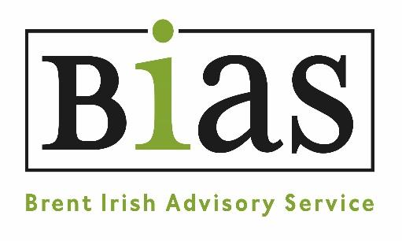 |  | Brent Irish Advisory Service  379-381 High Road,  Willesden,  NW10 2JR  email: Info@biasbrent.co.uk
APPLICATION FOR EMPLOYMENT
CONFIDENTIAL

Please complete this form and send your completed application via email to: info@biasbrent.co.uk

The information you provide on this form is the only information we will use in deciding whether you will be shortlisted for an interview. It is therefore essential that you complete the form fully and that you clearly demonstrate how you meet each point on the person specification. Please note that CVs are not accepted.

Position Applied For:
When would you be available to take up the post?
Please indicate whether you are available on the advertised interview date?
From which website, publication or other source did you FIRST learn of this vacancy?

Personal information and address for correspondence
First name(s)
Last name
Address

Postcode

Telephone home

Telephone work
May we contact you at work? |  | Yes/No

Mobile

Email
We will normally contact you by email. However, if you would prefer to be contacted using another method please let us know here:

Educational History

Please list any education, qualifications, and training that you have undertaken. We are particularly interested in professional and work-related qualifications and development relevant to the role applied for.
Dates | Course or Qualification (include grade where applicable) | Provider
.
Work Experience
Please include your current/previous employment (including job training schemes), voluntary work, community activities, school placements, time caring for dependants etc. Please put in date order, starting with the most recent

Employer’s name and address and type of business. | State position held and outline briefly the nature of the work and your responsibilities.
 | Dates: | From |  | To
 | Reasons for leaving:
 | Dates: |  | From |  | To
 | Reasons for leaving:
 | Dates: |  | From |  | To
 | Reasons for leaving:
 | Dates: |  | From |  | To
 | Reasons for leaving:

Supporting Information
It is essential that you complete this section in full. In this section we would like you to give specific information in support of your application. Taking each point of the person specification that states that it is needed in the application, demonstrate how you have all the necessary skills and abilities. As you type more space will become available, however your statement should be limited to no more than 2000 words.

1.

2.

3.

4.

5.

6.

7.

8.

9.

10.

11.

12.

13.

14.

Criminal convictions
Do you have any convictions, cautions, reprimands or final warnings that are not “protected” as defined by the Rehabilitation of Offenders Act 1974 (Exceptions) Order 1975 (as amended in 2013)? The amendments to the Exceptions Order 1975 (2013) provide that certain spent convictions and cautions are ‘protected’ and are not subject to disclosure to employers, and cannot be taken into account. | Yes / No
If YES please provide details of the offence and the date of conviction.

Having a criminal record will not necessarily bar you from working for BIAS – much will depend on the type of job you have applied for and the background and circumstances of your offence.
For some posts, an offer of employment will be subject to a DBS check.

References
Please give below the name and address of two referees who can comment on your suitability for the post. These should not include relatives or purely personal friends. If you have been employed we would normally seek a reference from your present or most recent employer. References will not normally be taken up until a conditional offer of employment is made.
Referee 1
Name
Organisation
Position Held
Address
Postcode
Telephone
Email
In which context does this referee know you?
Referee 2
Name
Organisation
Position Held
Address
Postcode
Telephone
Email
In which context does this referee know you?

Declaration
Data Protection: I consent to this information being processed and stored for the purpose of recruitment and selection at BIAS and if appointed, for the purposes of employment at BIAS

The information you give us on the application form will be used to help us decide whether to recruit you as a member of staff - this is our ‘legitimate interest’ under data protection law. It will only be seen by staff involved in the recruitment process, and will be stored securely.
If you are recruited, we will retain your contact information in order to involve and support you. We will also collect additional information, such as next of kin details, and over time records of training, support meetings and where relevant, appraisals. Again, it will be kept securely, and only those people who need to see your information in order to involve you will have access to it.
I confirm that to the best of my knowledge, the information I have provided on this application form is true and correct. I understand that if appointed on the basis of false information contained in this form, I may be summarily dismissed.

If you are sending your application form by e-mail, please mark this box ☐
(as a substitute for your signature) to confirm that you agree to the above declaration.
Signed: | Dated:

Please return this form to info@biasbrent.co.uk Closing date: Friday 4 June at midday.
We receive a large number of applications and are unable to respond to them individually. If you have not heard from us within two weeks on the closing date please assume you have not been successful.

