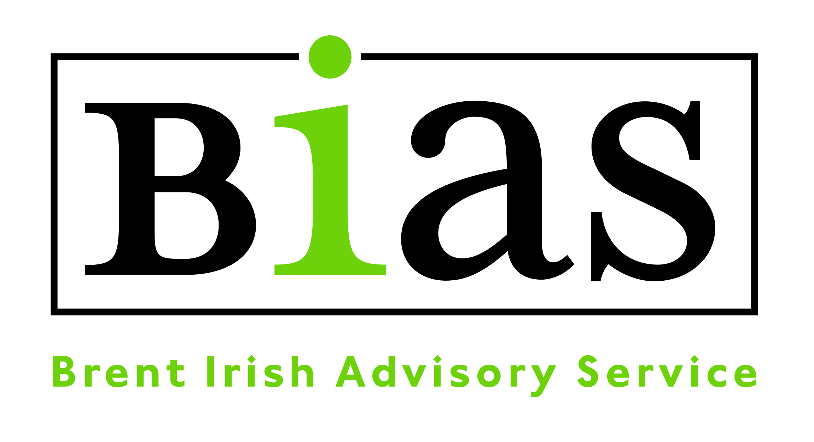

JOB DESCRIPTION

Title: Community Engagement Worker (COVID19)
Responsible to Director
Hours 7 -14 hours per week, including occasional evening or weekend work
Salary Grade £18-21K depending on experience/qualifications
Based: 379-381 High Road, Willesden and other locations primarily in Brent/Harrow
Contract: 4 months to be reviewed from start date

Because of the nature of our client group, a satisfactory enhanced level Disclosure will be required.

JOB PURPOSE

BIAS has supported the London’s largest Irish Community in Brent for forty years through a range of projects and services. This is an exciting opportunity for someone to help the Irish community through an Irish engagement (COVID19) project and promote BIAS.

We would like to appointment a dynamic, enthusiastic person to provide a hands-on approach to the delivery of this new engagement project. You will need to have strong people skills (to work with staff, volunteers and clients), and excellent organisational abilities to ensure the project is appropriately delivered and monitored.

The role is funded for the next four months and any extension will be subject COVID19 circumstances, performance and funding. This project is designed for a short-term intervention with the impacts of COVID19 on our community.

BIAS understand the benefits of one to one door step contact, alongside our telephone befriending service (which provides emotional support). BIAS also provides food parcels, client newsletters and potential online access. BIAS is considering all possible options help to improve well-being of the clients we support.

Overview of Post-Community Engagement Worker

MAIN DUTIES

PROJECT DEVELOPMENT and PARTNERSHIP WORK

- To provide one to one door step contact to members of the Irish Community
- This will enable BIAS to provide some emotional support and improve well-being of clients
- This may include allocation of food parcels and BIAS mail outs
- This may include some guidance on limited IT digital inclusion-door step but will need to be in line with UK Govt guidelines. Any such requests will need to be agreed beforehand with the Director and relevant PPE worn (mask, gloves and hand sanitiser)
- To provide basic advice and guidance and refer to BIAS advice team for (this may lead to undertaking direct referrals to both partner agencies or statutory services, supporting prescriptions).
- This may include the promotion and delivery of digital on line services to the Irish Community for example online Bingo or some form of contact chat. Options are being currently reviewed and BIAS members will need to be reviewed.
- Client information will need to recorded onto an excel sheet of any type of contact or help provided.
- A car will be required to travel to and from clients with relevant insurance and any mileage will need to be submitted on a monthly to claim back expenses.
- BIAS expects any member of the team to abide by UK Govt guidelines of social distancing and must at all times carry gloves, face masks and had sanitiser to ensure best practise (safety of the members we deal with and staff). PPE will need to be secured before visits can be arranged. Any one to one home step intervention to be agreed with Director/Advice Manager. Outreach visits to be clustered by location (list) for both safety and maximising contact.
- Represent BIAS in promoting its work within the Brent and the wider London area. BIAS expects outreach best practise to be adhered to (safety of staff -calls to advise when last appointment finished).
- Liaise with external organisations to promote partnership work and referrals

MONITORING & EVALUATION

- Provide weekly/monthly reports on project and be involved in team meetings

DIVERSITY & EQUAL OPPORTUNITIES

- Ensure compliance with the organisation’s equal opportunities policy and actively promote equal opportunities and diversity within your role

GENERAL
- Maintain confidentiality and professional boundaries at all times
- To carry out administrative tasks associated with the duties of the post and other duties as required by the Director or Board.
- Attend regular supervision with the Director/Advice Manager, and be willing to undertake training and professional development as needed.
- Maintain an awareness of legal and policy changes and good practice, as they affect the work of BIAS and in particular isolated people and volunteers.
- Maintain and develop Community information for people to access services

These are the normal duties which the employer will require from you at the date of your employment. However, it is necessary for all staff to be flexible in this respect and all employees may be required from time to time to perform other duties which are required for the efficient running of the organisation.

PERSON SPECIFICATION
This lists the skills, experience, knowledge, and abilities needed for this post. Please make sure that you refer to these in your supporting statement.

Person Specification – Community Engagement Worker
Essential criteria | Method of assessment
A minimum of two years working in a Community or Irish voluntary setting | A/I
Excellent verbal and written communication skills with the ability to  communicate effectively at all levels and to build good working relationships | A/I
IT - Good working knowledge of Microsoft Office, including Word, Excel, Powerpoint, Outlook and the internet | A/I
Ability to digest project briefs and deliver on time, on budget with outcomes | A /I
Excellent organisational skills and experience of working to tight deadlines whilst coping with competing priorities | A/I
Project
The ability to demonstrate patience, tact and empathy to staff, clients or volunteers | A/I
Ability to work in partnership with BIAS staff delivering the project | A/I
A car will be required to travel to and from clients with relevant insurance. | A
Experience of working co-operatively and effectively as part of a team and own initiative | A / I
Committed to the implementation of an equal opportunities policy. | / I
Maintain and develop community resource information for clients to access services  The post is subject to Section 5.2(d) of the Race Relations Act 1976 applies (Irish person or Irish background). | A / I
Desirable criteria
An understanding and awareness of the needs of the Irish Community and statutory and voluntary sector provision available | A/I

